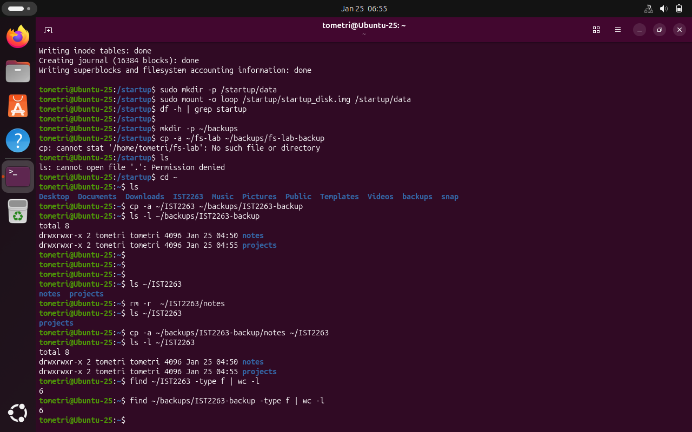
Checkpoint A: This was pretty straightforward, creating a folder for backups then copying the directory into the folder with a new directory. The backup directory was placed in the folder, which is useful in that it helps a user know what to expect.
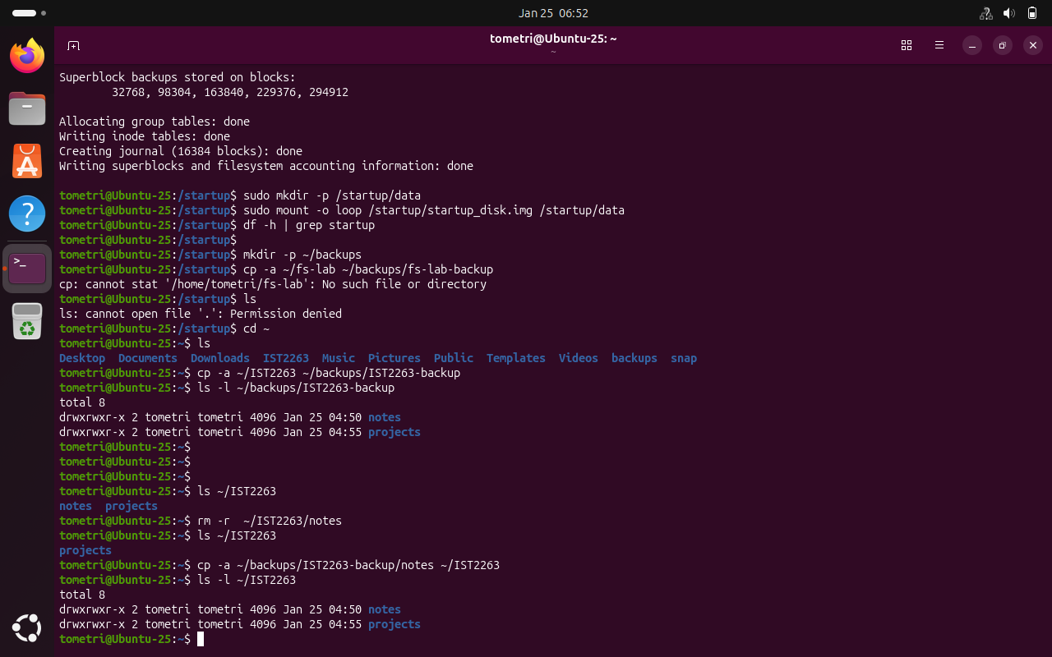
Checkpoint B: I chose to delete the notes subdirectory, and that was primarily due to seeming like it would be simple to remove then replace while saving some typing.
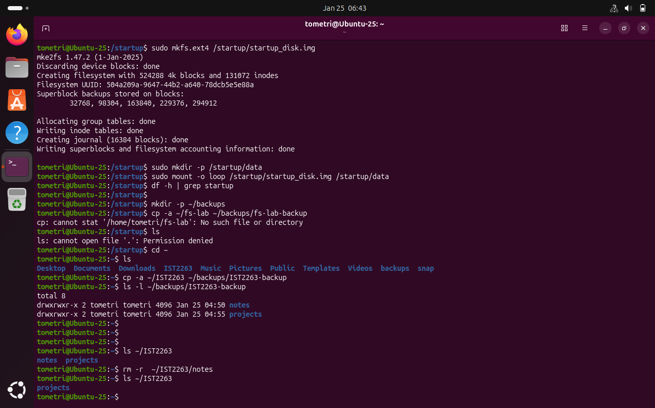
Checkpoint C: I just copied the notes sub directory back into the IST2263 directory , and verified so with the ls command as well gathering the file count.
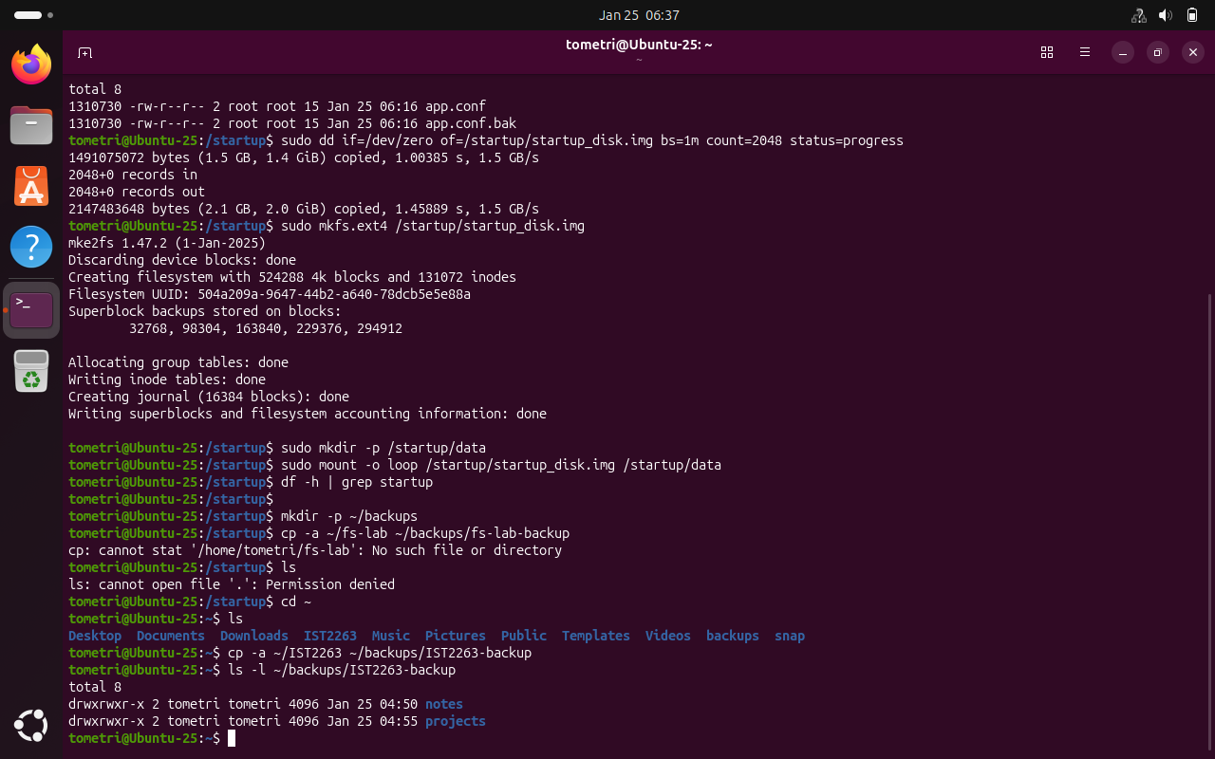
Verification.
In the industry there seem to be a few ways of backing up critical data: the 3-2-1 rule, frequent backups, intelligent cloud backups, full/incremental/differential/block-level, and etc. I’m personally a fan of the 3-2-1 rule and some of its variations as it allows me to do a mix of things such as having multiple backups local, or cloud based and is flexible while being efficient. Every company should back up what they consider to be critical such as employee records, contracts, compliance files, and anything that is required for operation.

